Individual Development Assessment (IDA)
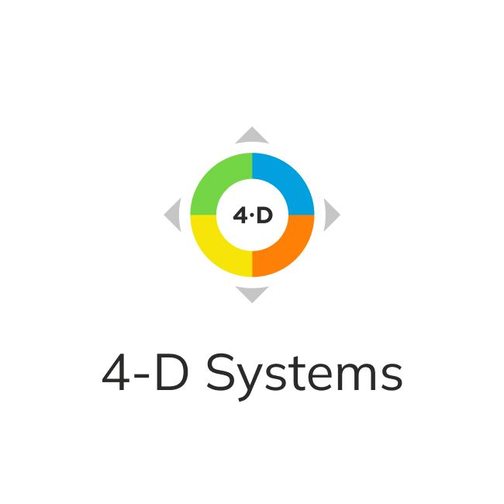
By Charles J. Pellerin

A QUICK GUIDE

Commitment to your confidentiality
4-D Systems representatives, authorized by Charles J. Pellerin, will not provide any data in the IDA report to anyone but the assessed individual, unless they have her or his official request to do otherwise.

IDA request form (Individual Development Assessment)
Your Individual Development Assessment process has the following stages:
- Fill out the IDA application form at least 7 days before the assessment and email it to galarich@me.com. In the application, please indicate: country, city, company name, IDA dates, name and surname and email of the contact person
- After receiving the application we will contact you and discuss payment terms
- After the payment, an IDA link will be sent to the e-mail address you provided.
- Send the link to all your IDA participants (6-20 people you know more than 3 months).
- After completing IDA you will receive the generated report in 4 working days in PDF format.

Expert support
Galina Nagovitsyna officially authorized by Charles Pellerin to train and certify 4-D consultants/trainers/providers ; 4-D Consultant/Business Coach PCC ICF Coach galarich@me.com
Olga Mityushkina, 4-D Systems Project Manager, 4-D Consultant/Business Coach, PCC ICF Coach olqa.mityushkina@gmail.com

The Eight Assessed Behaviors
- Expressing Authentic Appreciation
- Addressing Shared Interests
- Appropriately Including Others
- Keeping All Your Agreements
- Expressing Reality-based Optimism
- Being 100% Outcome Committed
- Resisting Blaming or Complaining
- Clarifying Roles, Accountability and Authority (RAAs)

